**BANK APPLICATION SCREEN SHOTS**

This application is designed for

1. Bank Employees to maintain all the accounts and transactions
2. Account customers to login to the account to check transactions and to transfer, withdraw or deposit money.

If the user of the application belongs to bank side then he/she can be able to login into**“USER LOGIN”.** If user of the application is outside customer then he/she can be able to login into **“CUSTOMER LOGIN”.**

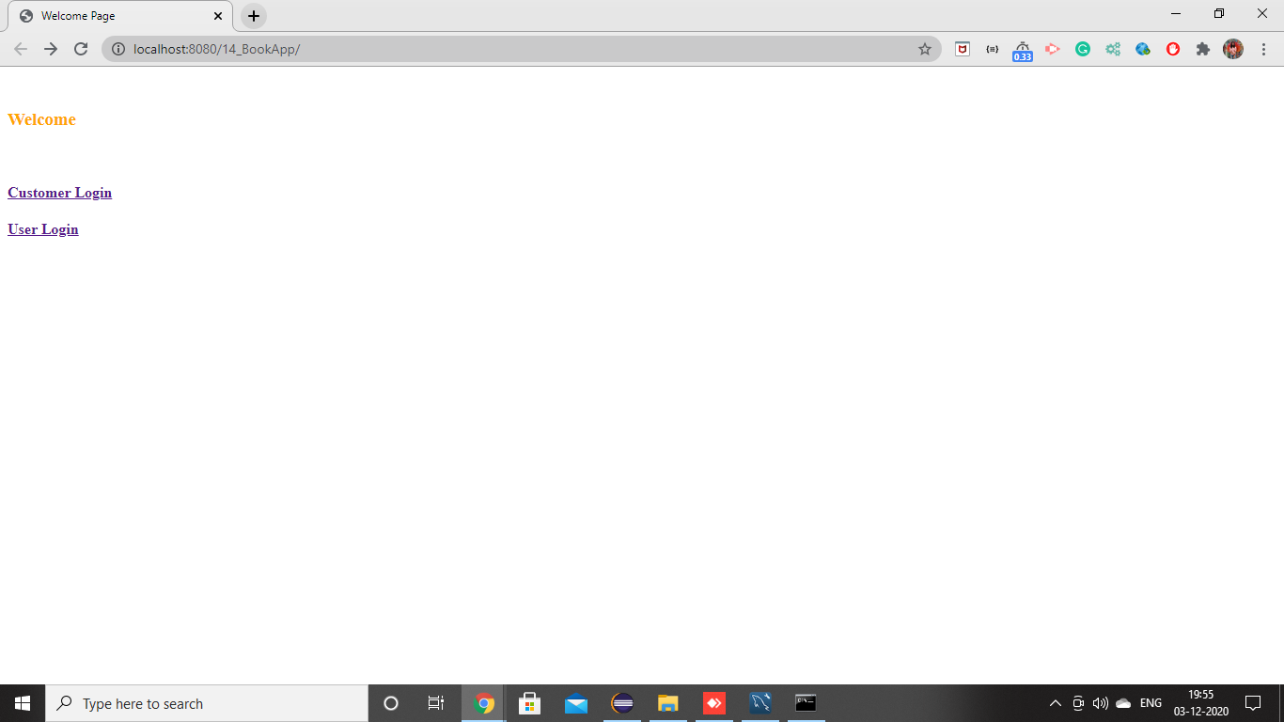

**1. BANK EMPLOYEES Pages**

1. Validation on login page to enter the user details

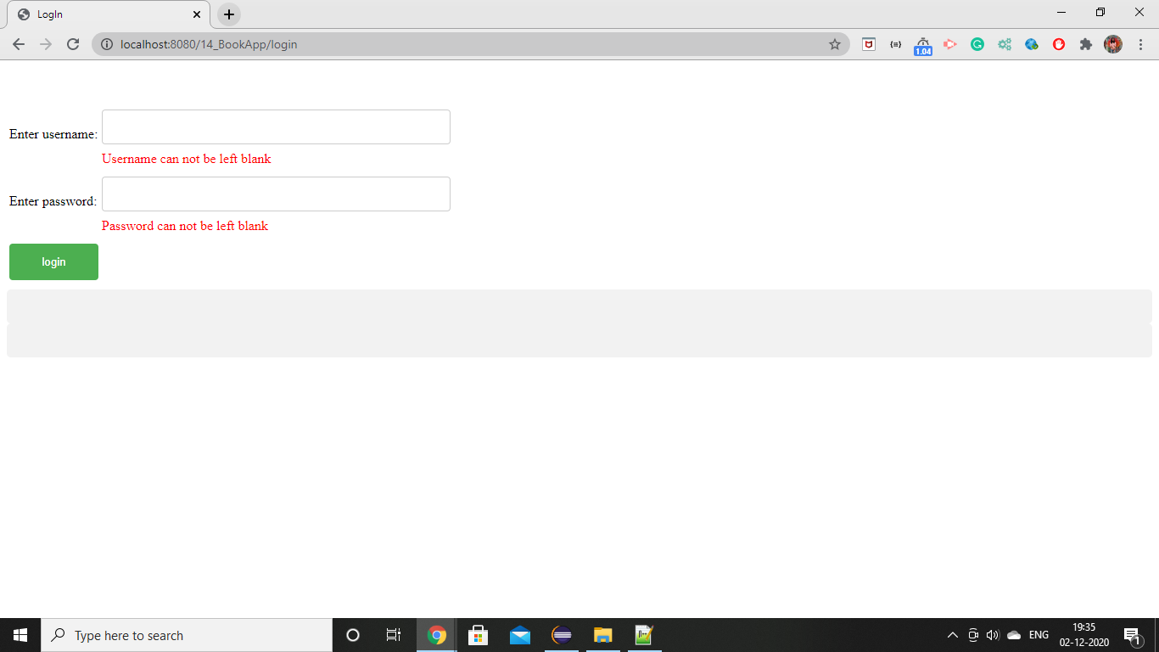

2. If username and password wrong!

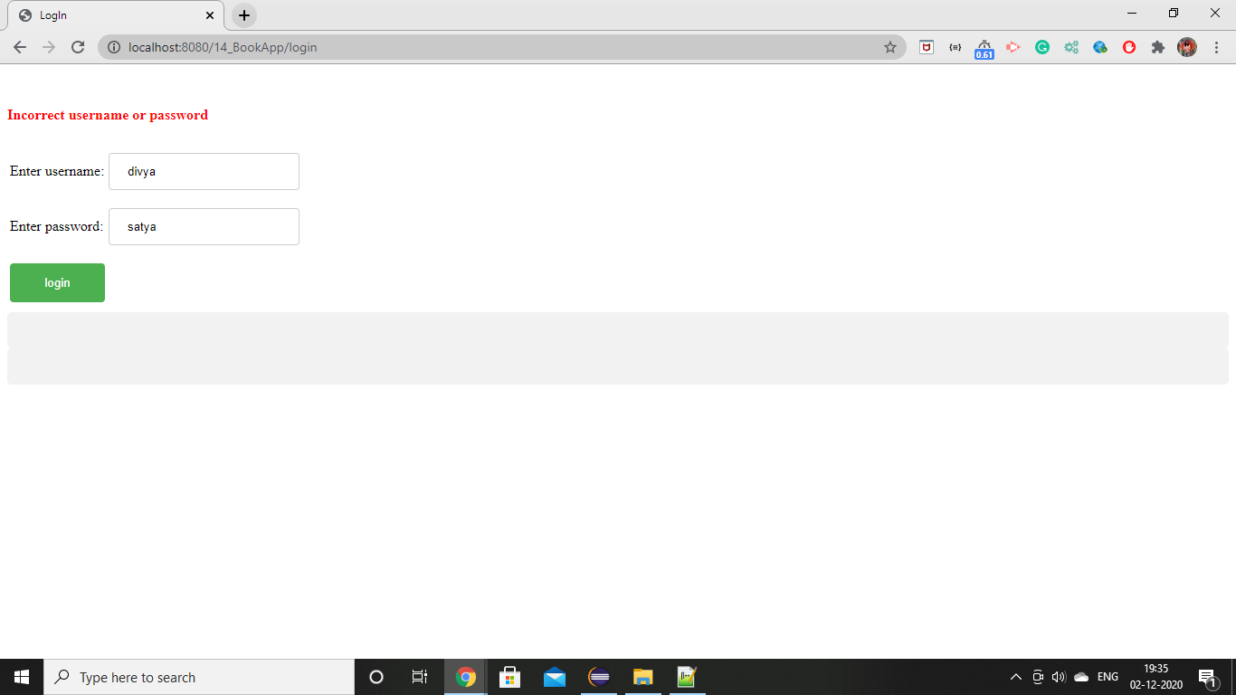

3. If username and password are correct and if the user is “**ADMIN**” then it goes to admin home page, if user is “**Manager**” it goes to manager home page, if user is “**Clerk**” then it goes to clerk home page.

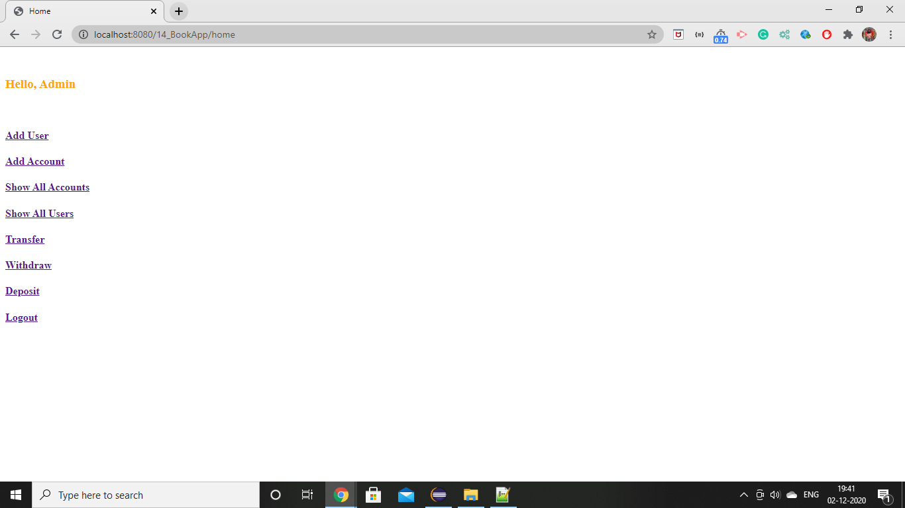

4. Admin can able to

1. Create, read, delete and update User
2. Create, read, delete and update Account
3. Transfer, withdraw, deposit by checking validations

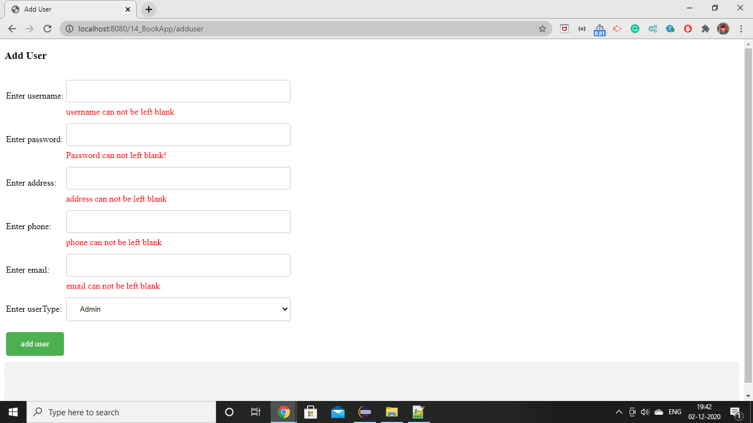

5. The forms gets submitted once the admin enters the correct details.

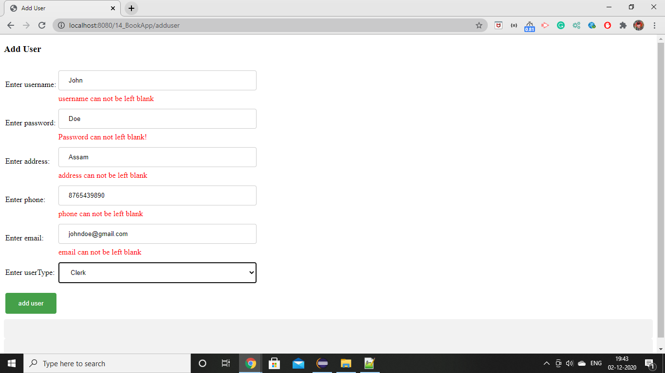

6.Once admin submits the form data gets stored into database, new user is added (john) and admin can able to update and delete the user.

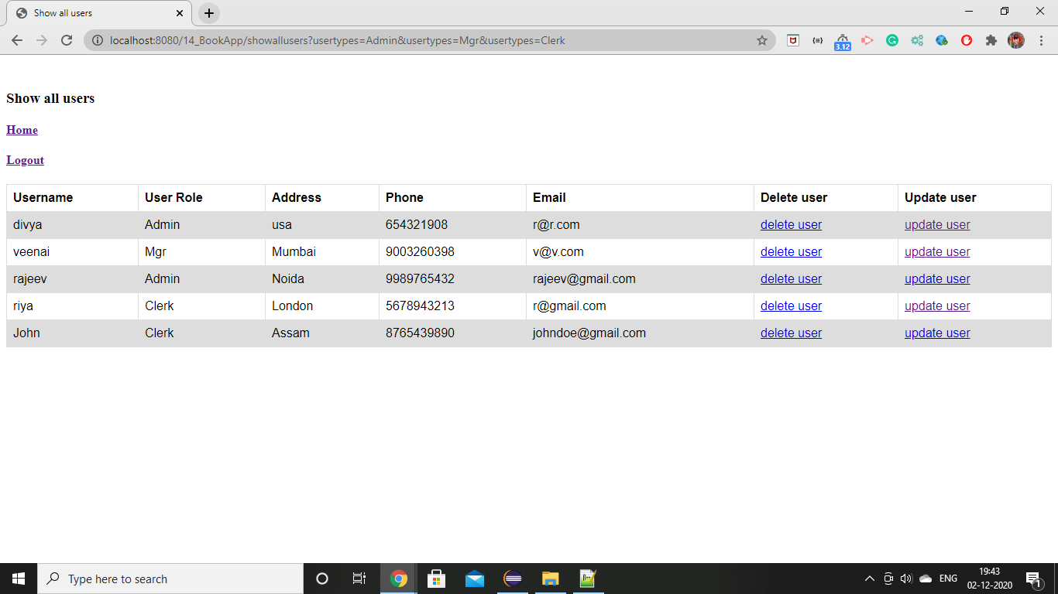

7. Updated user1 and user2 details.

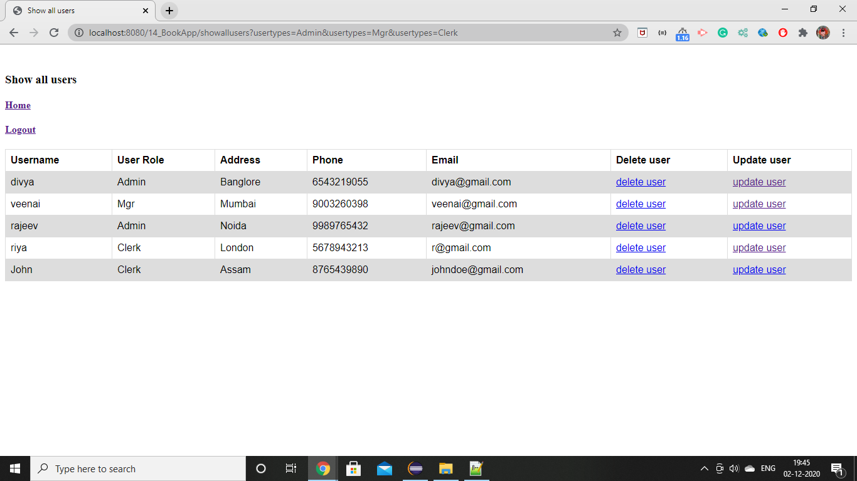

8. Deleted user4

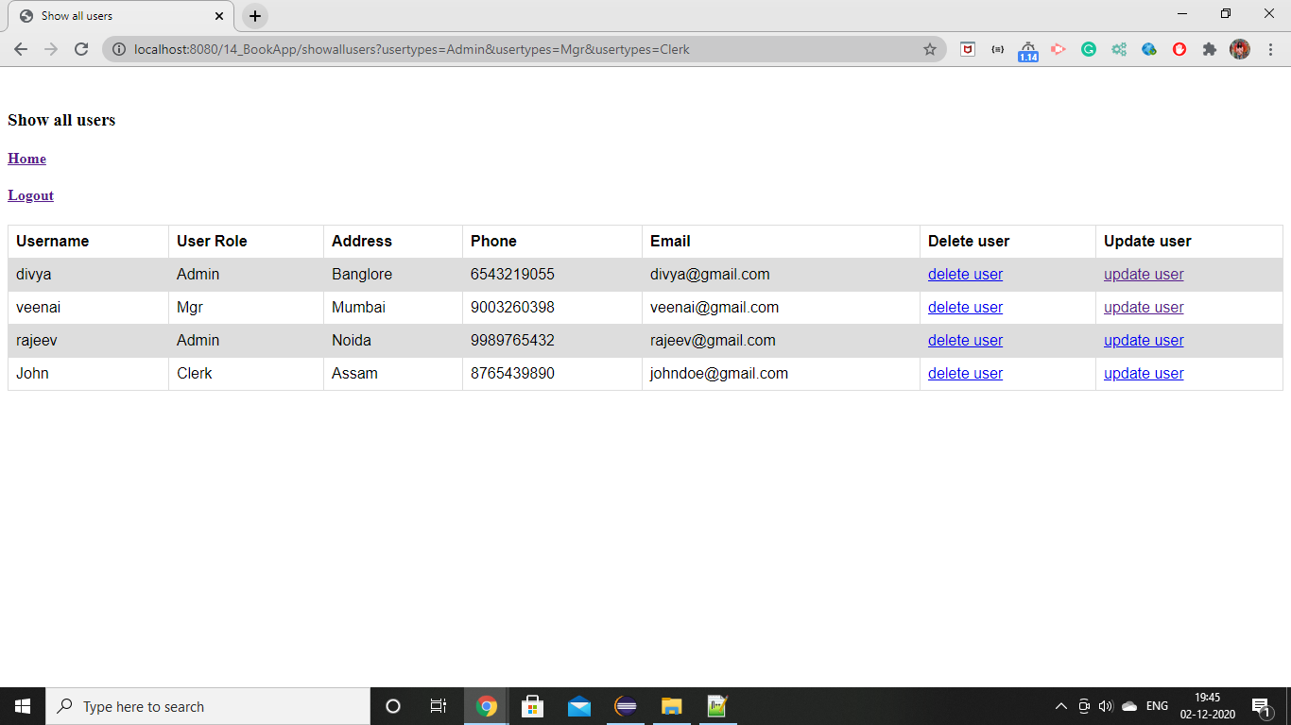

9. Similarlly, admin can be able to create, read, delete and update the account, if validation is proper.

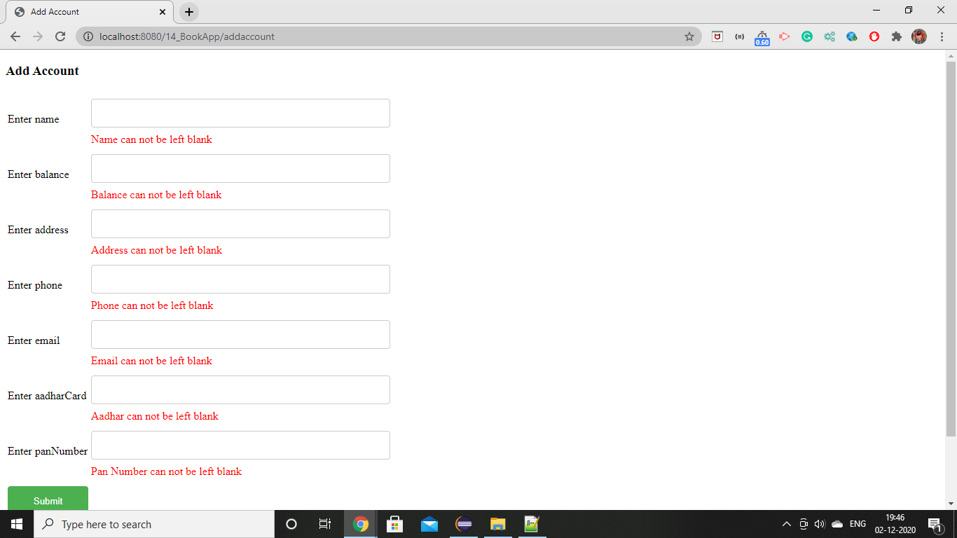

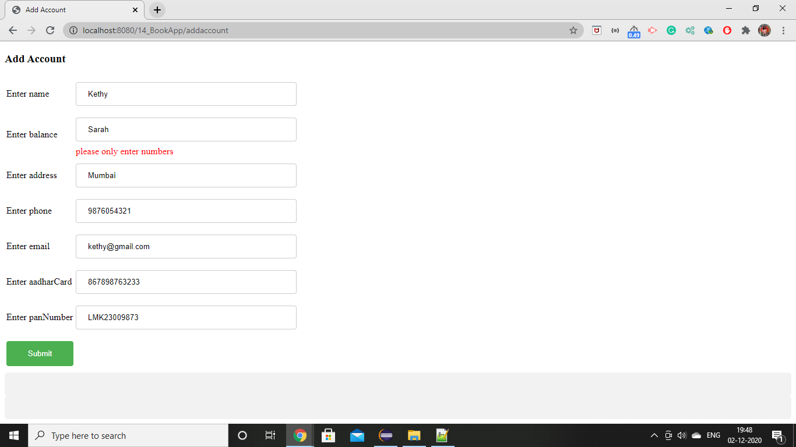

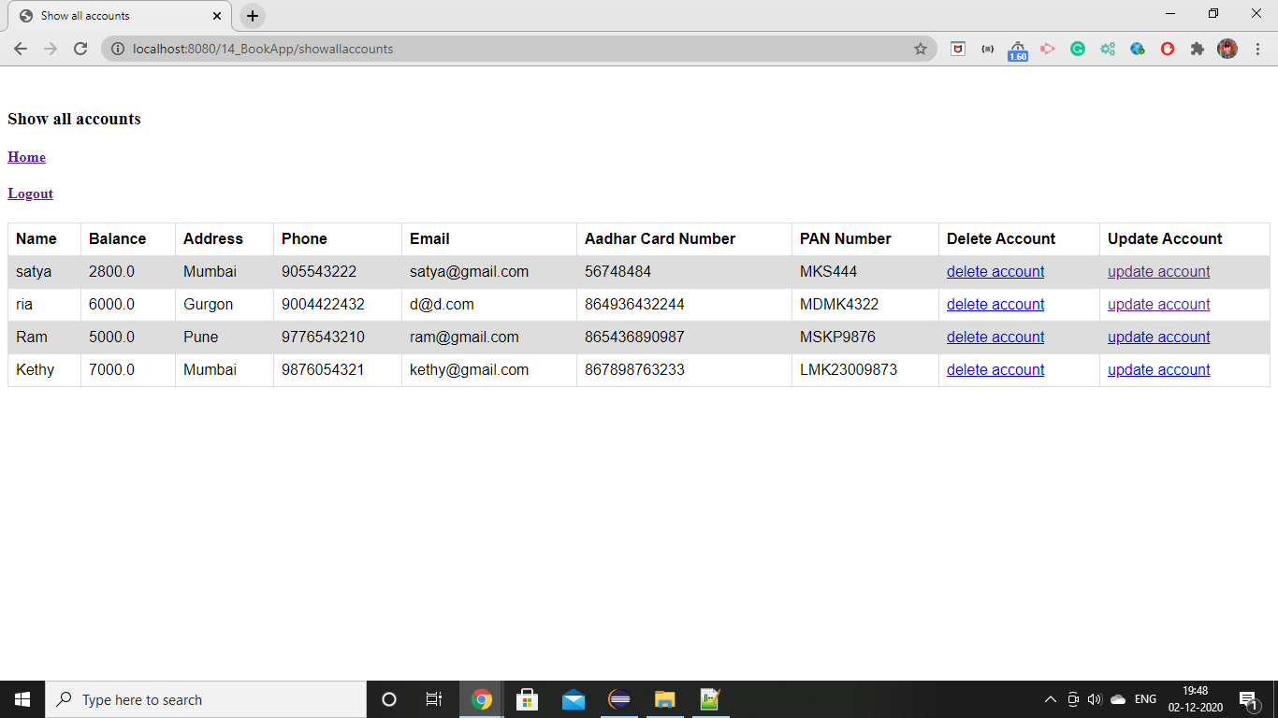

* Updated account details and no one can able to change name and balance.

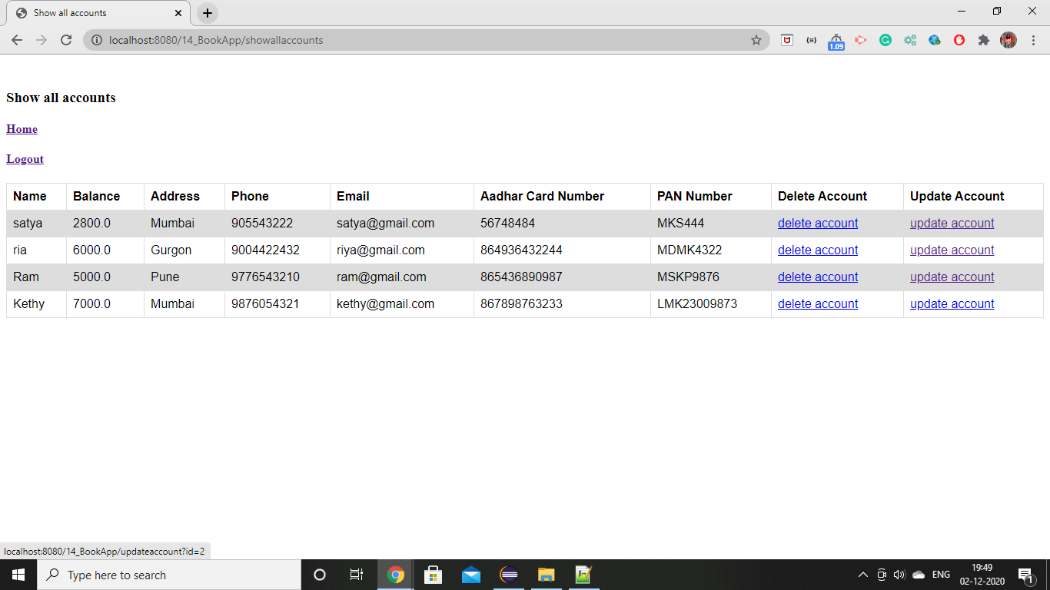

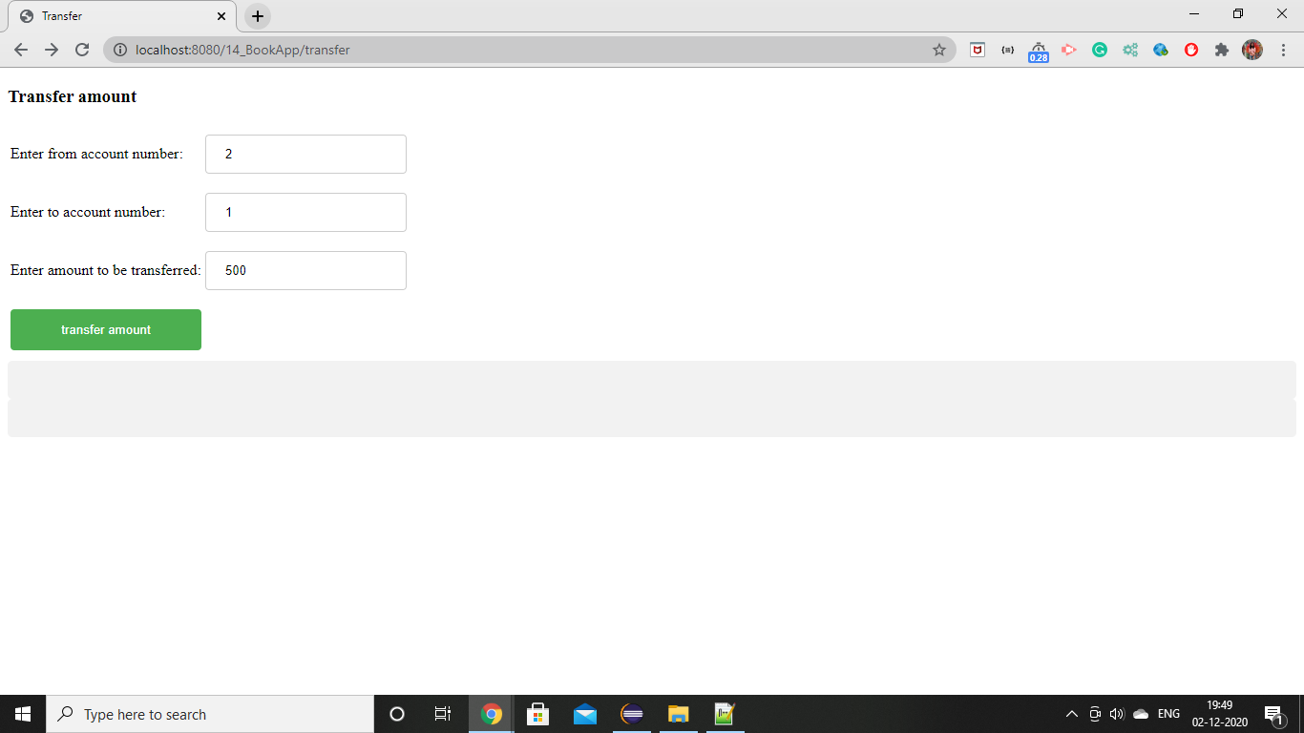

* Once transaction is success then admin gets redirected to success page with respective success message.

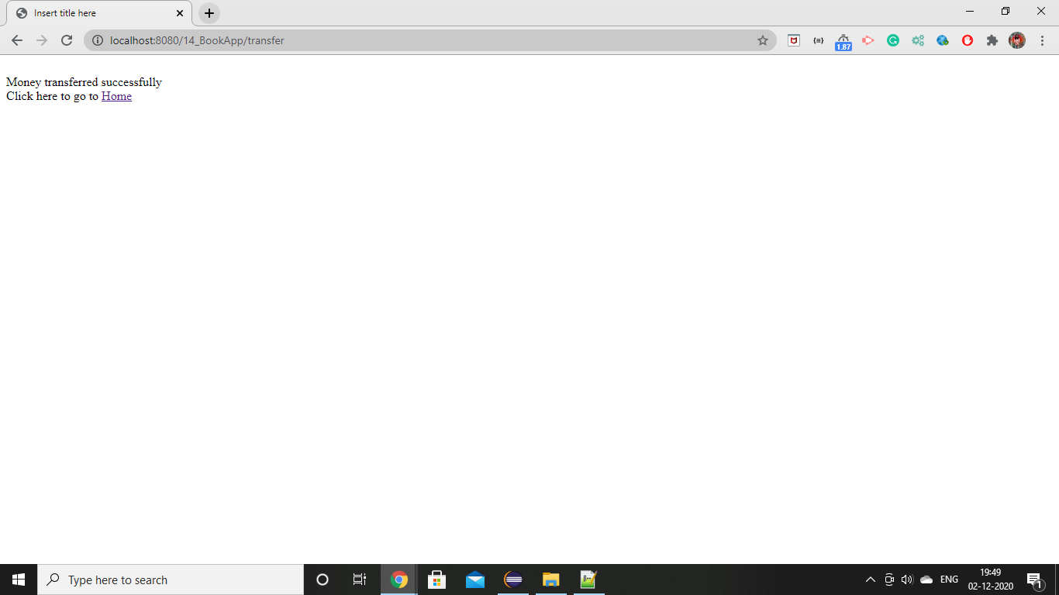

* Deposit amount and withdraw amount page

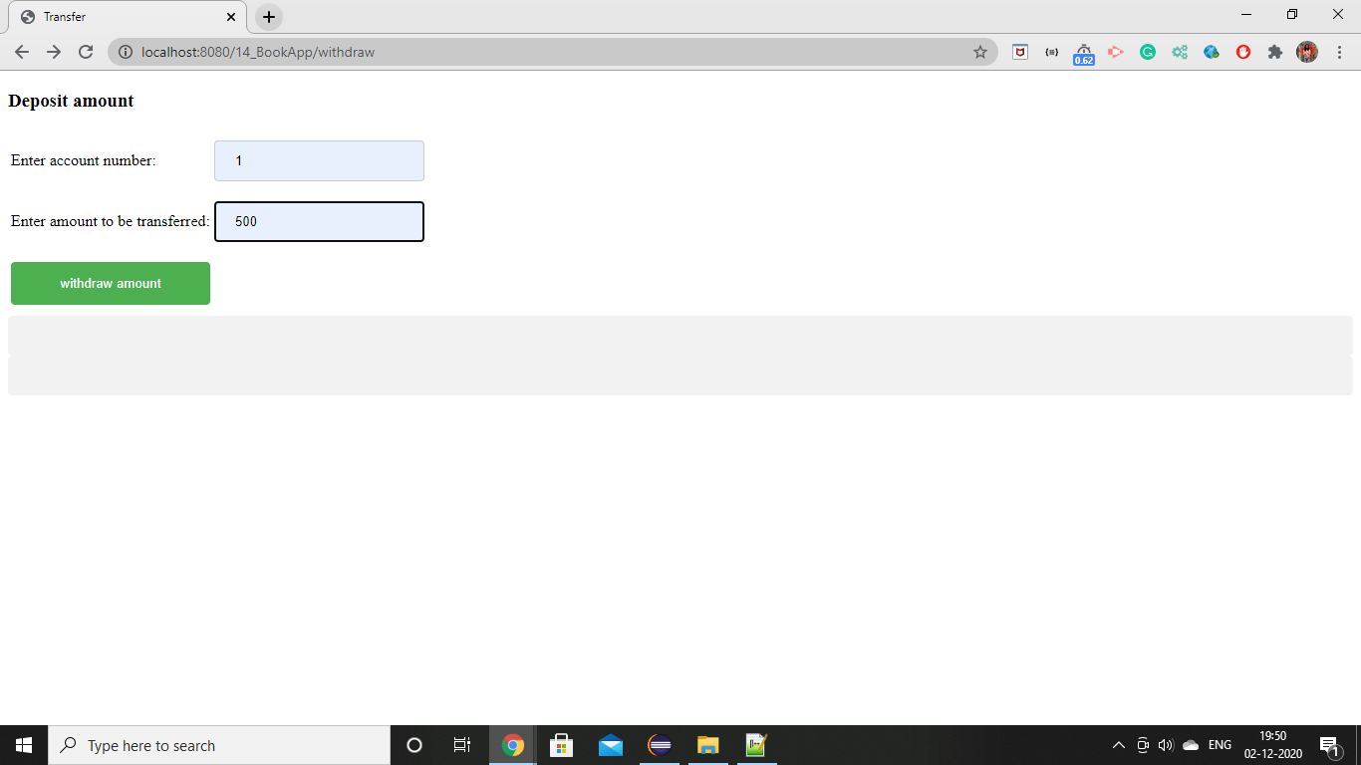

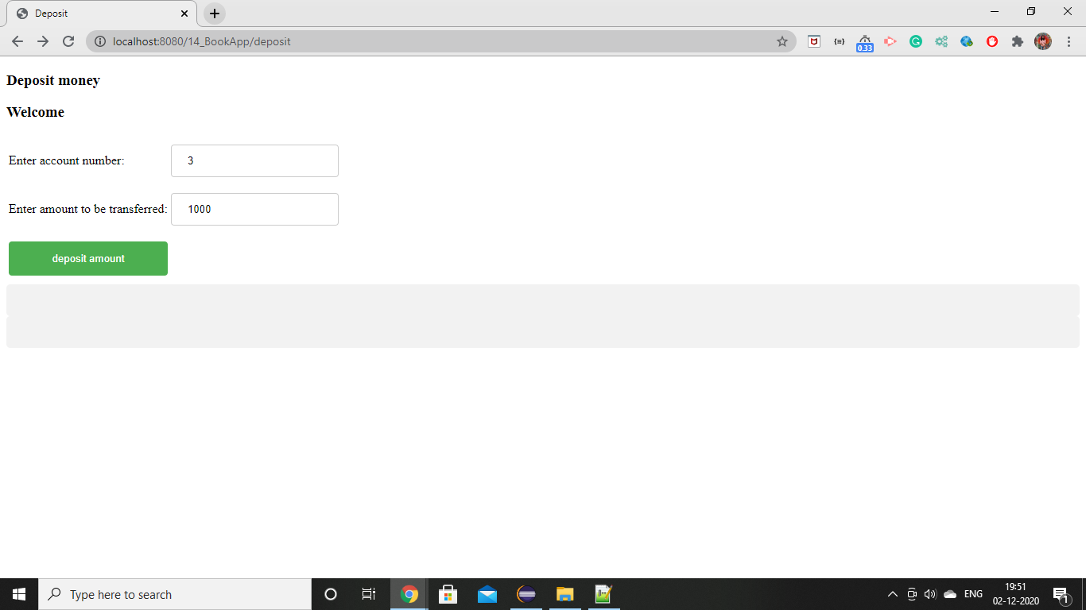

* Success message page after depositing and withdrawing amount.

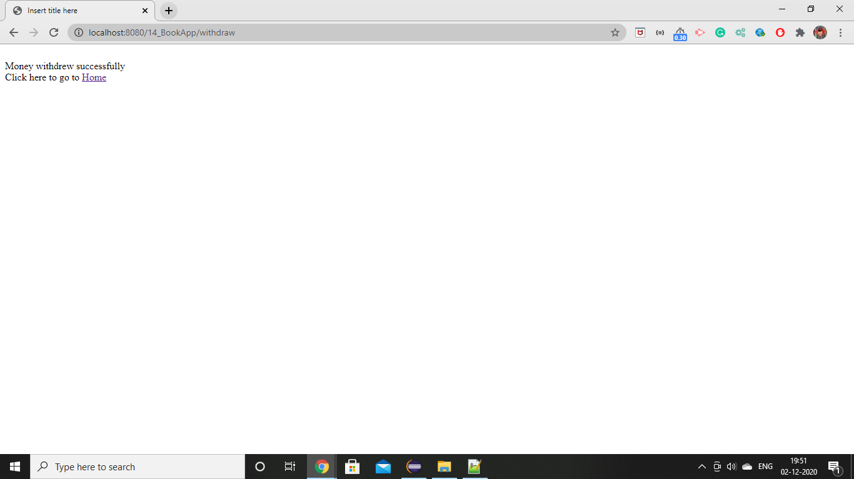

* **Manager, manager also performs almost all similar operations like user except adding new user and new account.**

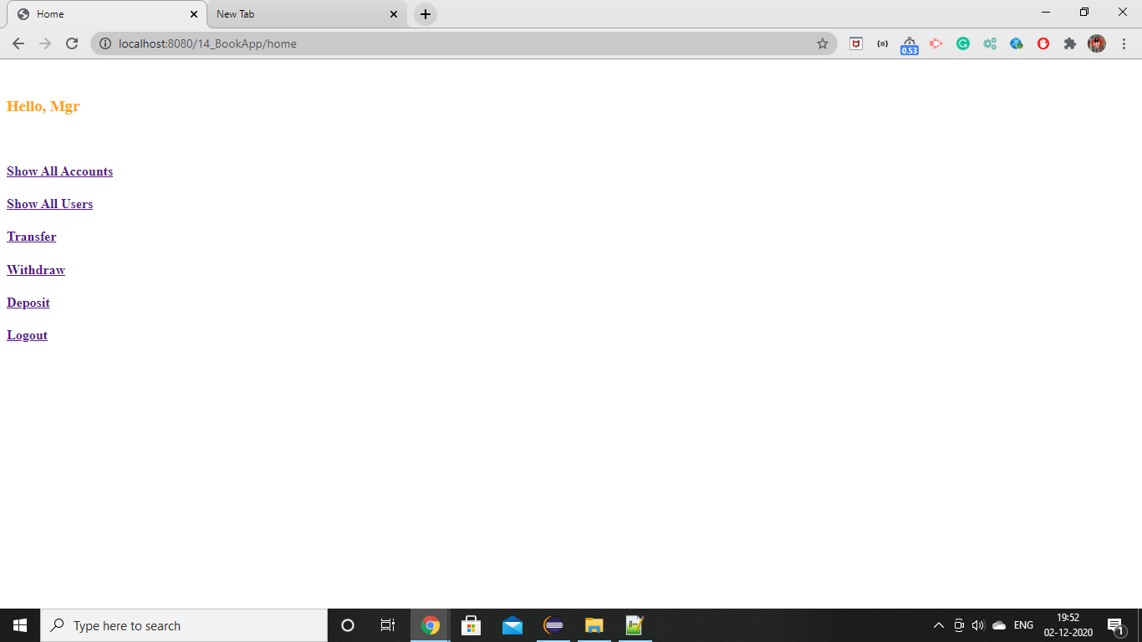

* **Clerk**
* Clerk cannot update and delete the account but can able to view all the transaction history.

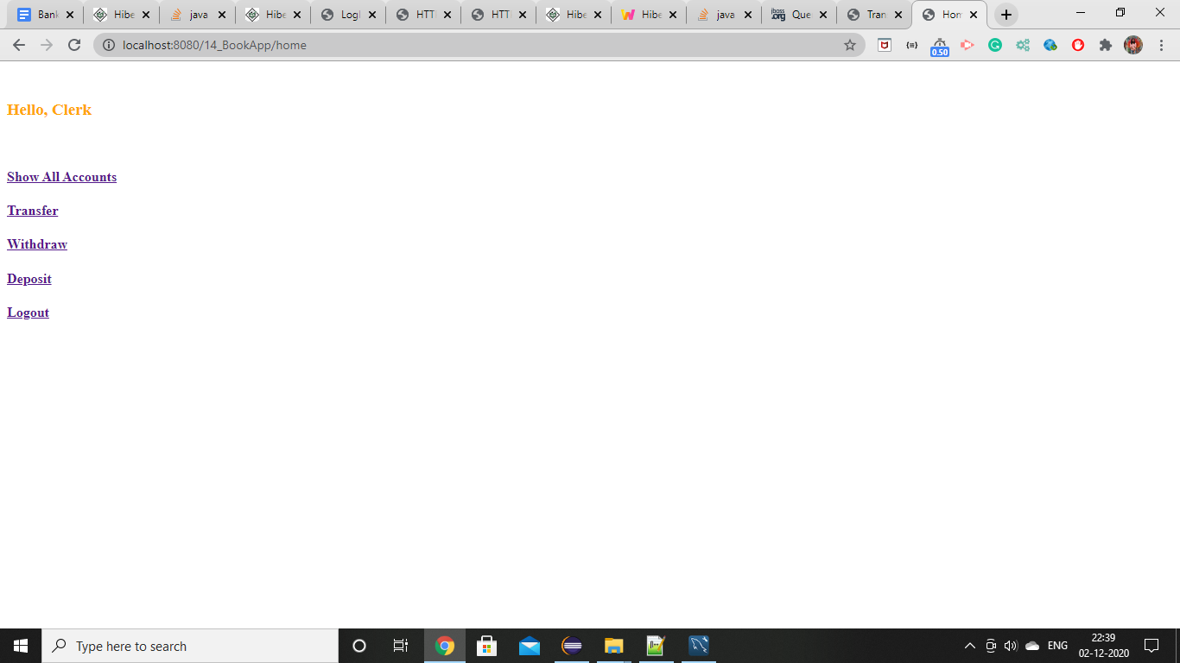

* When clicked on show all accounts all the accounts gets displayed but clerk can not modify the account instead clerk can be able to get all the transactions from particular account.

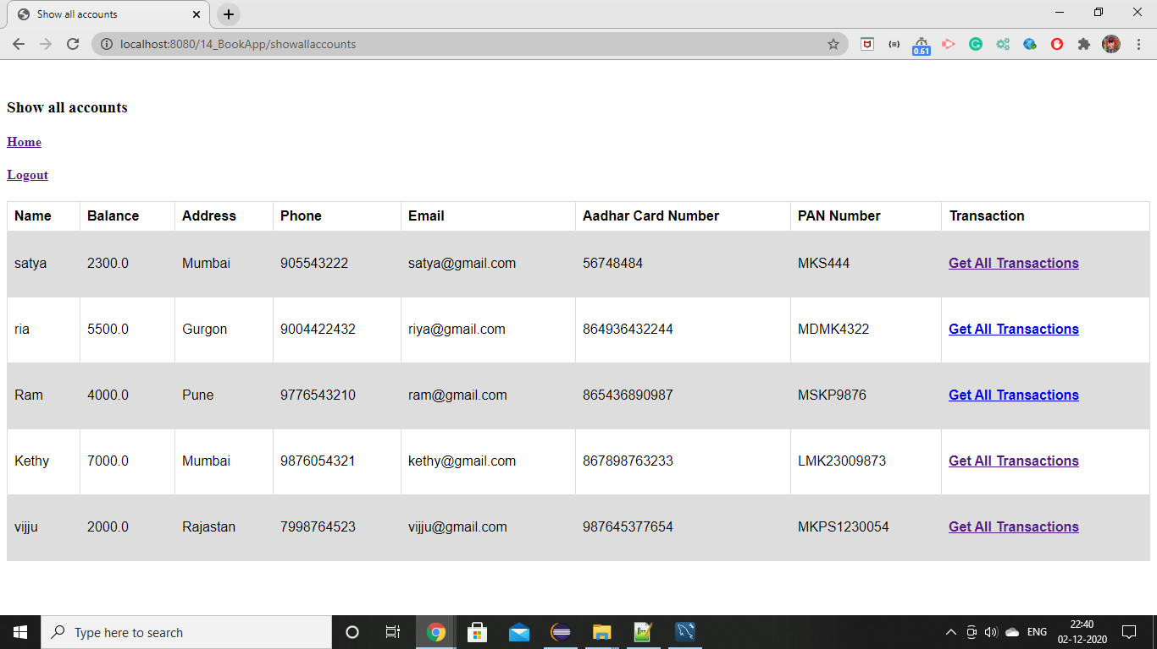

* Transaction History of account1

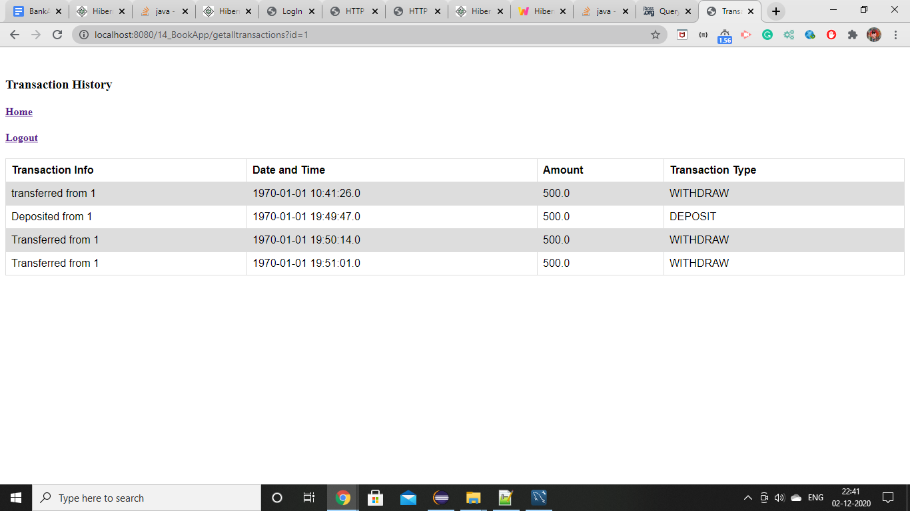

* Transaction history of account2

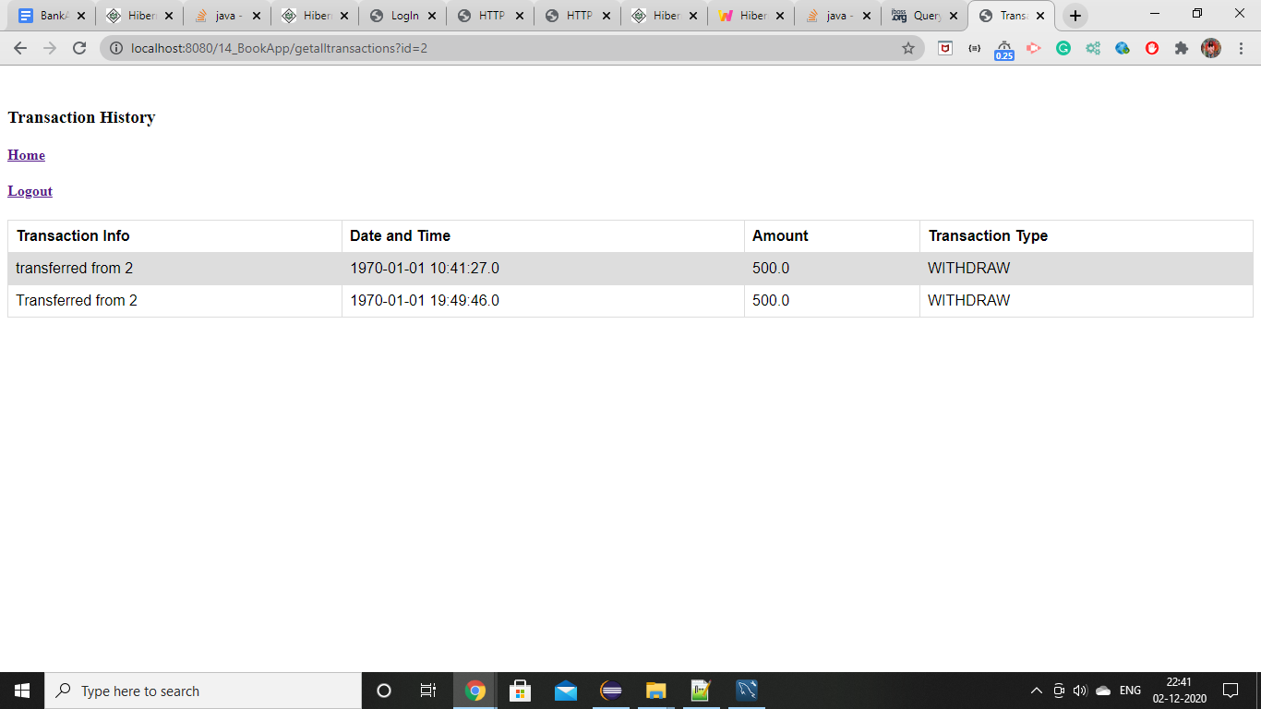

-Transferred from account3 to account4

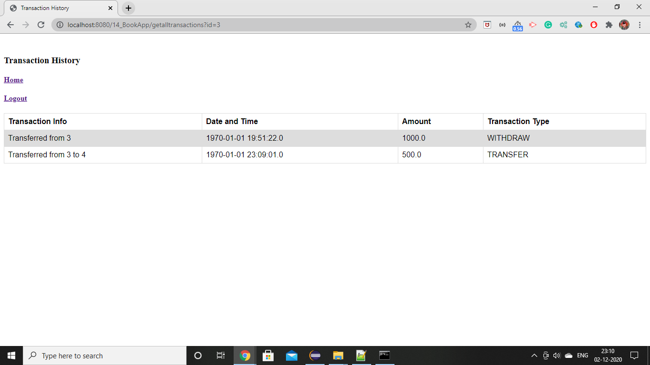

* Credited to account4 from account3 with transaction information.

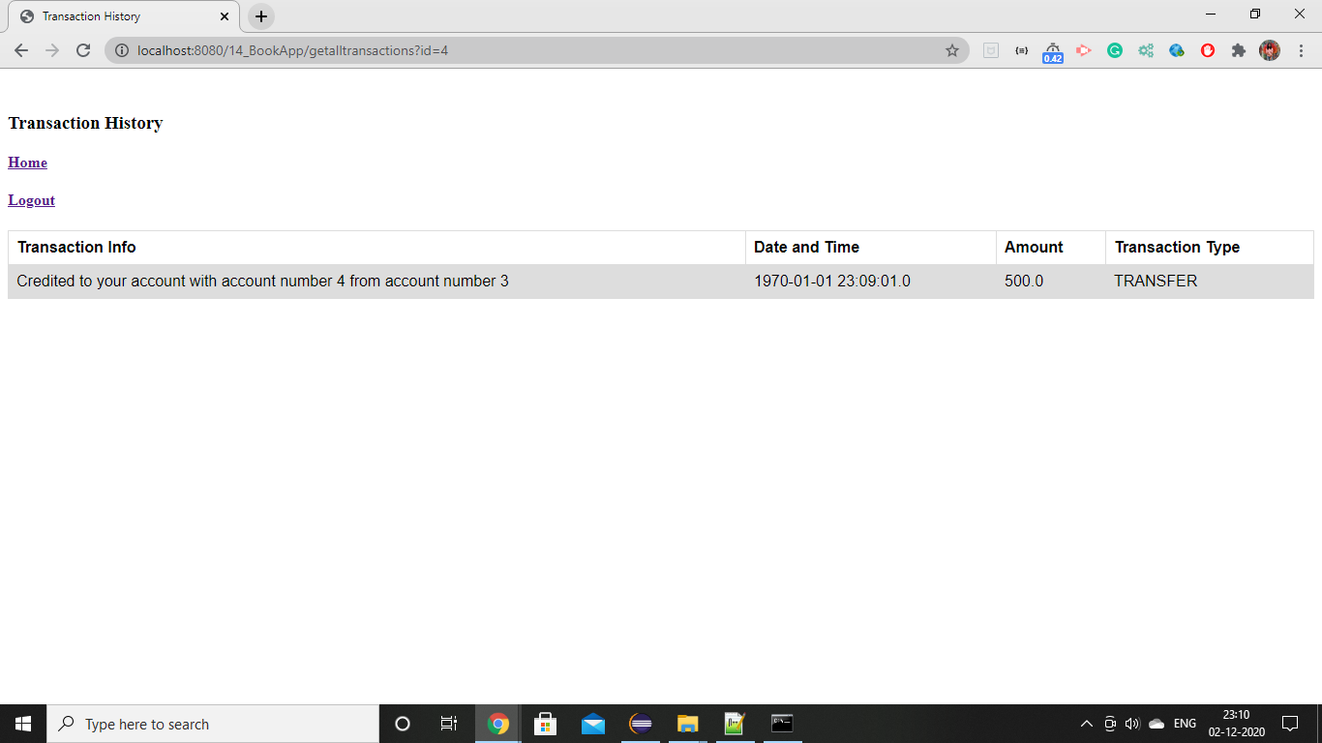

* If someone try to login using some random name which is not stored in db.

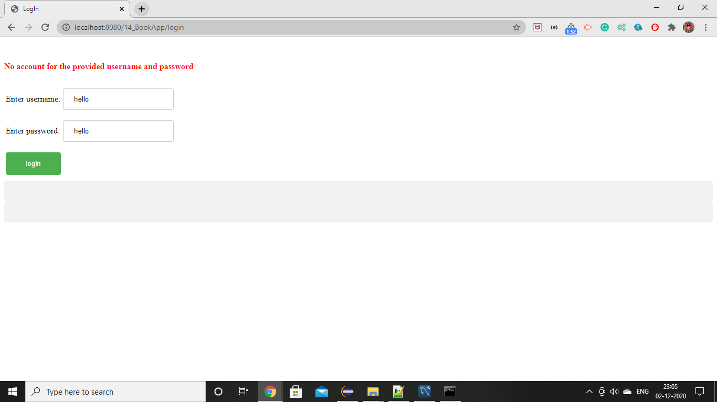

**2. CUSTOMER LOGIN PAGES**

If customer is already registered then he can login to his/her account using credentials.

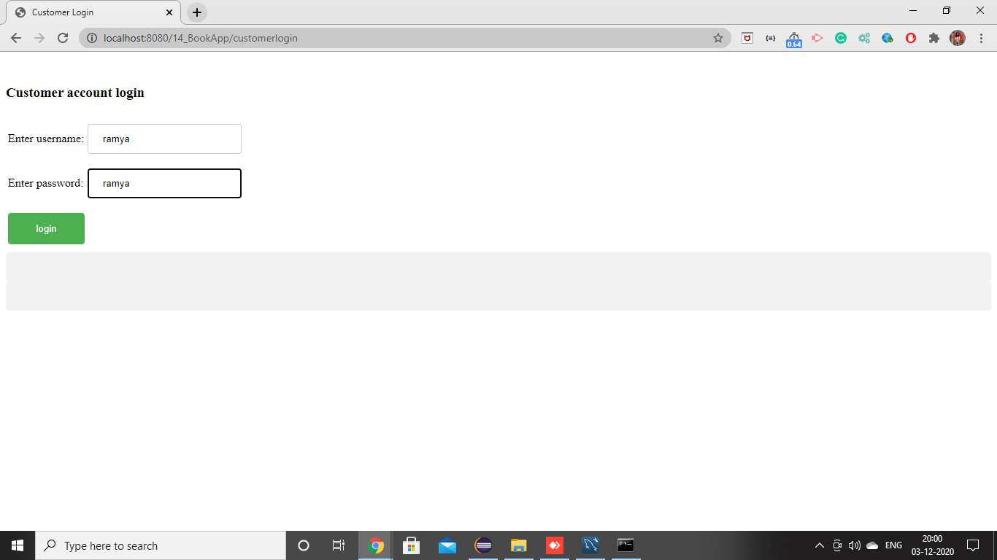

* Once customer gets lo he can able to see his account number and can able to perform withdraw, transfer, deposit and transaction history operations.

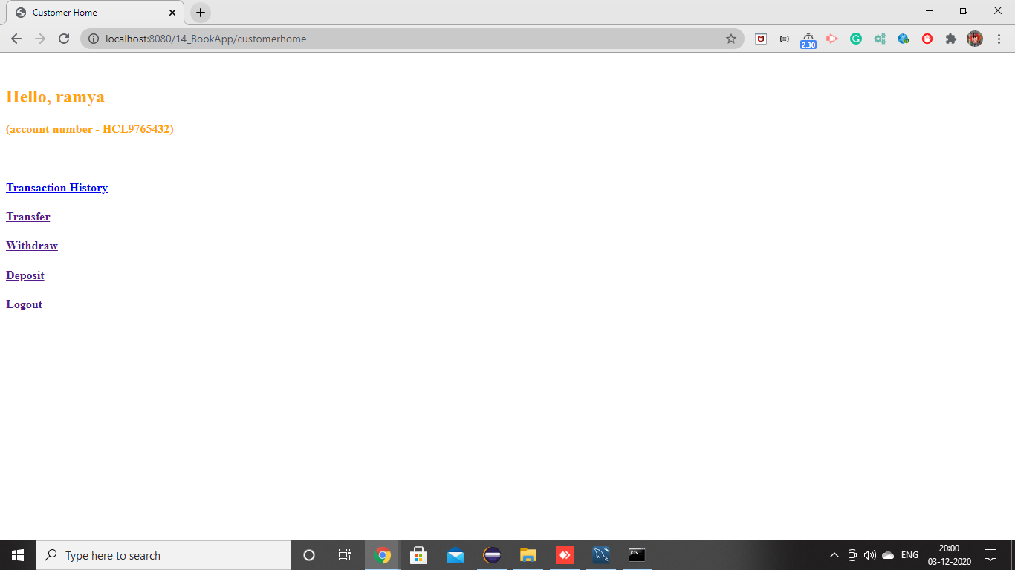

* While transferring the money from the customer amount the value of the from customer is disable to enter any new value. So, that transaction takes place correctly.

